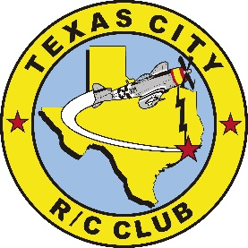 TCRCC Meeting Minutes – June 24, 2023
13 members present 76 current members
President – Vince Hoechten Meeting called to order on 06/24/2023 at 10:01 am.
Vice president- Keith Boydston
Secretary – Robert Petrash
Treasurer – Steven Rhodes
Upcoming Events
2023 Events

Helicopter event Oct. 6th ,7th and 8th Training seminar/clinic before the event, clinic benefits the club
Cubs & Cousins October 13th and 14th
Possible swap meet with NASA, date to be determined
Night Fly, date to be determined.

Two day events will allow for more out of town visitors to attend

Events committee chairman is Larry Ammons, and as always volunteers are needed for:
- Registration
- Raffle
- Swap meet
- Parking
- Air Boss
- Chefs/Kitchen

Items discussed at the June meeting:
Reminder, be courteous of members who are speaking at meetings, one at a time. (Robert’s Rule)
- CD volunteer needed for events
- More volunteers needed for club work
- FRIA, FAA Recognized Identification Area; our application has been sent to FAA for approval.
- Altitude restrictions, 400 ft. discussion and request to raise to higher limit; also waiting for FAA approval.
- The discussion on arming electric planes in pit area was tabled

Club projects
- Mower shed work, new siding is needed.
- Lights at clubhouse Completed Thanks to Todd Nolte and Mike Goza
- Volunteers will be needed for all projects

June 7th , the club invited 19 kids out to the field from Texas City to get exposure to RC. The kids enjoyed simulators and watched club members fly their planes.

Meeting adjourned at 10:34

Secretary
Robert Petrash
281-813-9523

